**CNN algorithm**

In neural networks, Convolutional neural network (ConvNets or CNNs) is one of the main categories to do images recognition, images classifications. Objects detections, recognition faces etc., are some of the areas where CNNs are widely used.

CNN image classifications takes an input image, process it and classify it under certain categories. Computers sees an input image as array of pixels and it depends on the image resolution. Based on the image resolution, it will see h x w x d( h = Height, w = Width, d = Dimension ). Eg., An image of 6 x 6 x 3 array of matrix of RGB (3 refers to RGB values) and an image of 4 x 4 x 1 array of matrix of grayscale image.

Technically, deep learning CNN models to train and test, each input image will pass it through a series of convolution layers with filters (Kernals), Pooling, fully connected layers (FC) and apply Softmax function to classify an object with probabilistic values between 0 and 1. The below figure is a complete flow of CNN to process an input image and classifies the objects based on values.

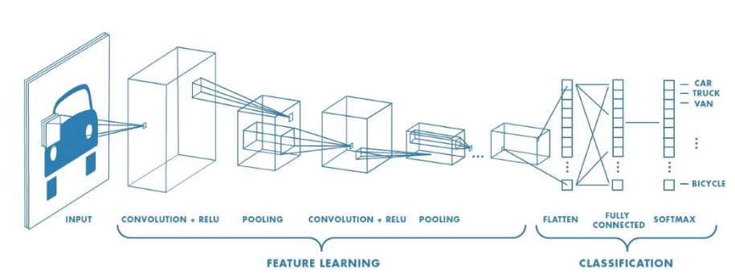

**Step1: Convolution Layer**

Convolution is the first layer to extract features from an input image. Convolution preserves the relationship between pixels by learning image features using small squares of input data. It is a mathematical operation that takes two inputs such as image matrix and a filter or kernal

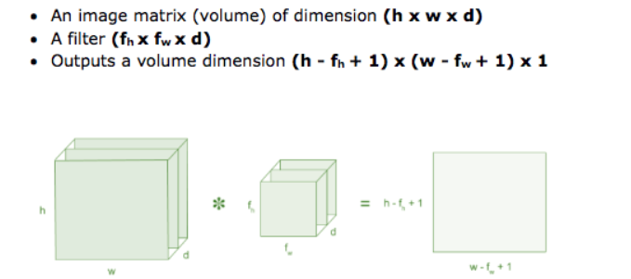

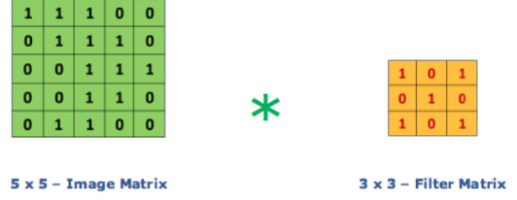

**Step2: Pooling Layer**

Pooling layers section would reduce the number of parameters when the images are too large. Spatial pooling also called subsampling or downsampling which reduces the dimensionality of each map but retains the important information. Spatial pooling can be of different types:

* Max Pooling
* Average Pooling
* Sum Pooling

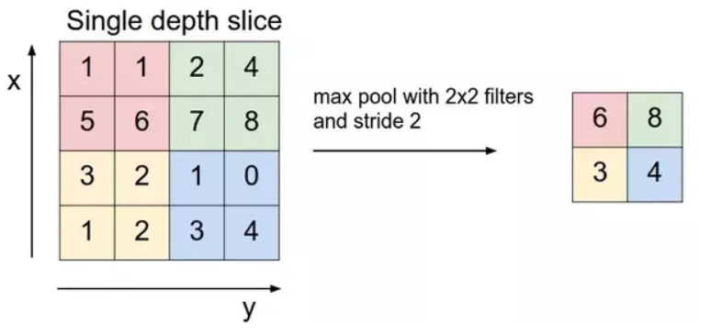

**Step3: Fully Connected Layer**

The layer we call as FC layer, we flattened our matrix into vector and feed it into a fully connected layer like neural network.

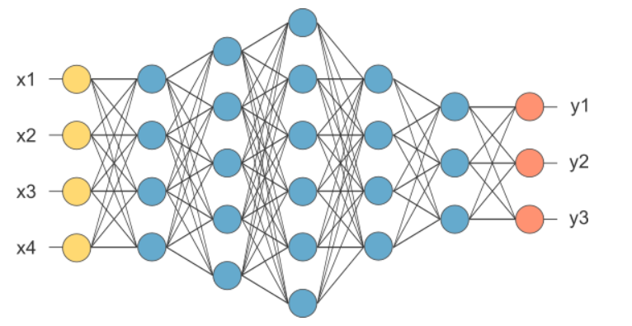

In the above diagram, feature map matrix will be converted as vector (x1, x2, x3, …). With the fully connected layers, we combined these features together to create a model. Finally, we have an activation function such as softmax or sigmoid to classify the outputs as cat, dog, car, truck etc.

